# WASH 9HP

## PROFESSIONAL WASHING MACHINE

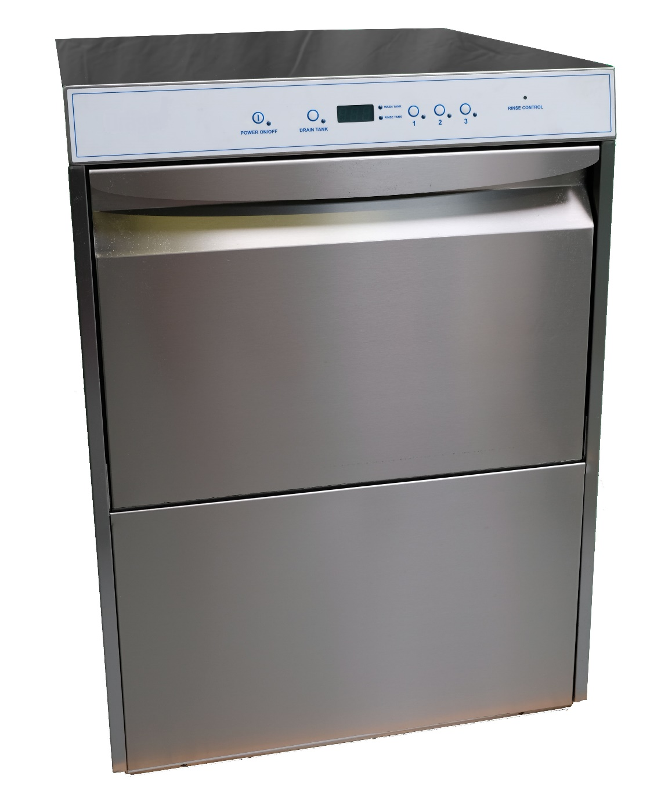

Version June 2025

### Function

The washing machine Wash9HP is ideally suited for the safe cleansing of breathing masks/face pieces and SCBA’s. This takes place in combination with a cleanser based on a product which is liquid, mildly alkaline and phosphate and chlorine-free, while the neutralizing agent (applied after the rinsing agent) is based on citric acid.

The difference from the normal Wash9 is that the Wash9HP is equipped with a high-pressure connection for pressurised washing of 1 SCBA.

### Description

The washing machine is very compactly build in order to occupy as little space as possible. It is made entirely of stainless steel type 304 and is insulated against heat loss and noise emission.

In order to be able to cleanse the inside of the machine properly and easily, all corners are rounded and there are no sharp objects. Also the rotating stainless steel washing and rinsing arms with sprayers and the stainless steel sieve are easily removed.

The controls have been kept extremely simple, namely by 3 push-buttons for 3 different wash times ; 5, 10 or 21 minutes. You can read out the temperature for the tank and the boiler on the digital display.

The cleansing agent is dosed very precisely via a hose pump. The neutralizing agent is processed in the same way but with its own pump.

The machine has a low consumption of both water and electricity since the warm water of each rinsing is used and only the after-rinse is done with clean water from the boiler. This achieves a water consumption of 9 liters per cycle while the dirtiest water is removed. If required, it is possible to directly connect the machine to the warm water supply (max. 50 °C.).

After the final rinse, you switch on the water removal pump in order to empty the tank.

With the cleansing machine, a stainless steel fine wire basket (A20) is supplied as standard. This basket also fits the M18 and M45 models drying cabinets.

### Technical details:

The electronics, which operate all the units, has several sensors. Warning messages displayed on the control panel. A temperature safety device, which limits the temperature in the case of any breakdown, has been mounted on the boiler.

A door switch ensures that the machine does not start until the door is properly shut.

A clear signal lamp and LED-display indicate that the machine is in operation.

The washing machine must be connected to the power supply of 400 Volt, 3 phases, neutral conductor, and earthen.

The water connection is G 3/4" and a non-return valve has been installed through the user (in accordance to local regulations). The water hardness must be between 2-4° dH, otherwise a water softener system is recommended.

### Maintenance:

The cleansing machine is easy to clean since it is made entirely of stainless steel. The inside part, such as the spray arms and sieves, can be easily removed so that a hygienic operation is guaranteed.

### Model:

Wash9 for a maximum of 9 breathing masks (depending of model or type of masks) or 1 SCBA

### Advantages compared to other washing machines:

* Specialy engineered en designed for breathing maskes.
* Supplied with high pressure connection for SCBA
* very fast cleansing cycles
* the masks do not need to be transferred to another basket
* lower consumption of both water and electrical energy
* simple to operate
* low noise level when in use
* virtually maintenance-free
* long life cycle
* a high quality product

## PROFESSIONAL WASHING MACHINE TYPE WASH9

### Specifications

Dimensions height x width x depth in mm

External 850 x 600 x 620

Internal 340 x 540 x 480

Weight 68 kg

Noise volume 70 dB(A)

External grinded stainless steel type 304

Internal stainless steel type 304

Doors 1 piece front (door Security/Emergency stop)

Feet’s 4 pieces adjustable for stability

Water connection /supply G 3/4" to max. 50 °C. water hardness 2-4˚dH

Water pressure 1,5 - 7 bar

Recommended water flow 20 litre/minute

Water consumption 9 litres per wash cycle

Cleansing time approx. 5, 10 or 21 minutes

Wash tank content 23 litres

Temperature wash water 52 °C.

Rinse tank content 12 litres

Temperature rinse water 55 °C.

Temperature reading by LED reading

Temperature safety software: high level limit

Heating wash tank 2,0 kW

Heating rinse tank 4,5 kW

Water drain hose ø 29 mm

Hose pumps 1 x for dosage cleaning agent and 1 x for the neutralizing agent

Capacity max.9 breathing masks/face pieces per wash cycle

Number of wire baskets 1 piece (A03)

also fitting in our drying cabinets type M18 and M45

High pressure system minimum 100bar, maximum 150bar, G5/8” connection

Cleansing agent doses 4 ml per liter (advice: Suma Jade)

Neutralizing agent doses 0,5 ml per liter (advice: Suma Med Neutral)

(other doses can be set at the factory or by a service technician)

### Connections

Voltage 5-pole CEE-plug, 400 Volt AC,   
3 phases, N + PE, 50-60 Hz.

Power 5,3 kW, fused at 3 x 16 Ampère

Water supply connection G ¾” max. 50°C.

Water drain Ø 29 mm

Maximum height drain hose 200 mm without syphon

High pressure system G5/8” connection

Optional Accessories

* A13: Stainless steel support frame

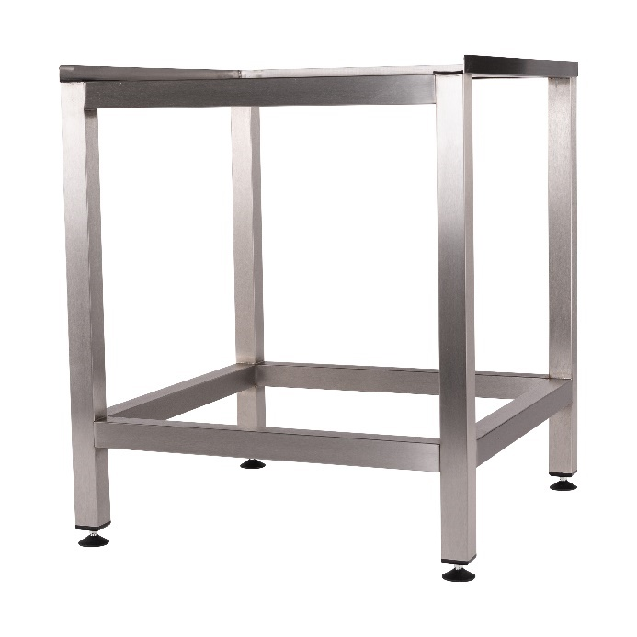

* A14: Stainless steel support frame closed with 1 door

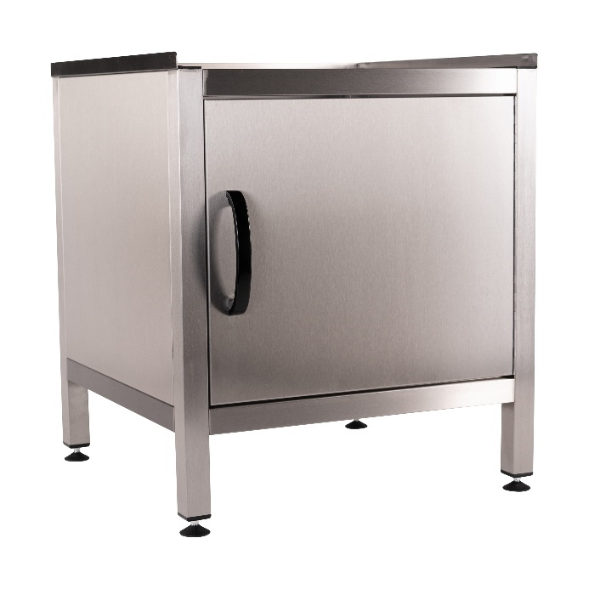

* A56: stainless steel fine mesh basket with 12 compartments and cover

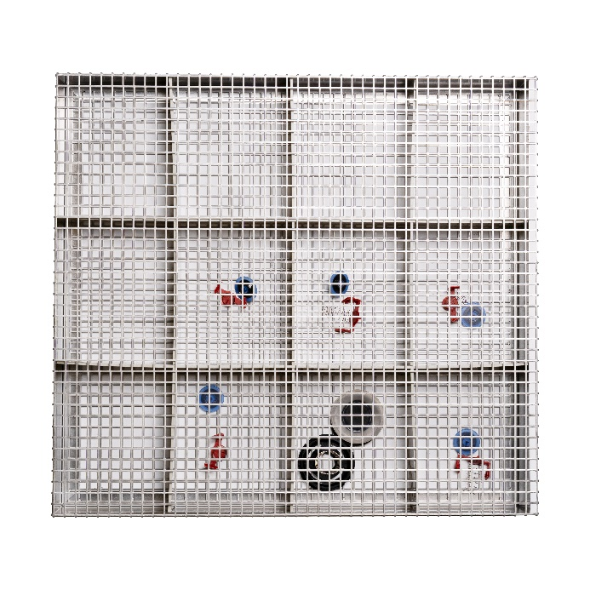

* A910: stainless steel fine mesh basket with 6 compartments and cover

