M45U

DRYING CABINET

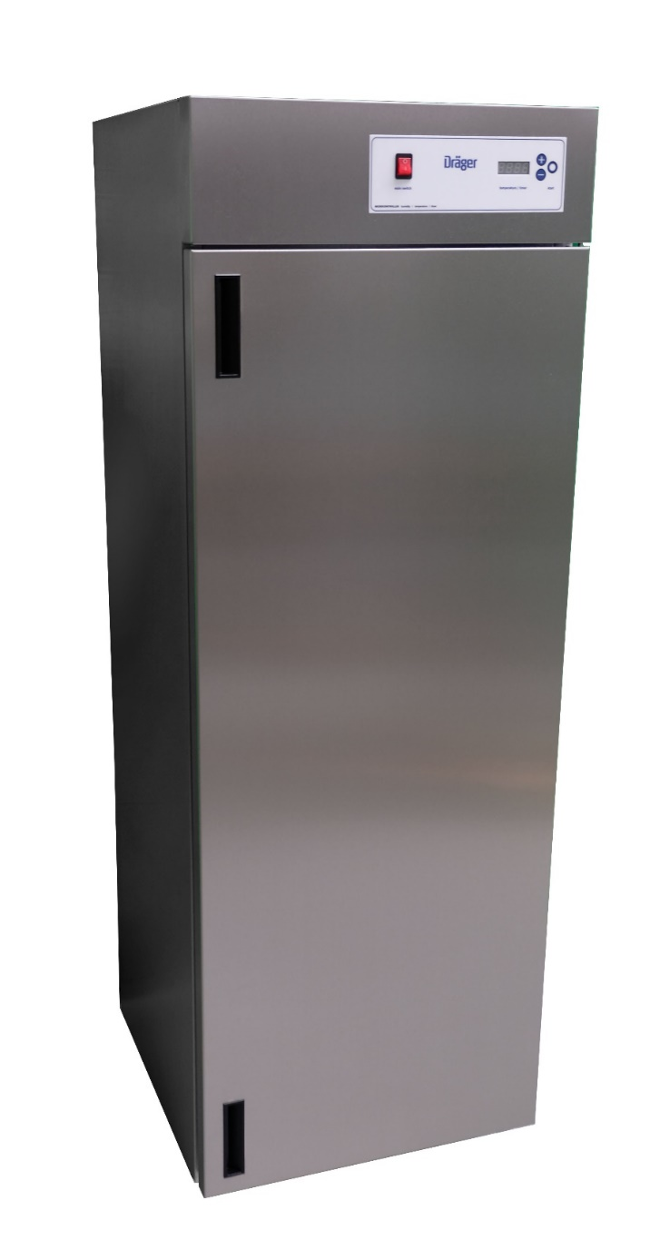

Version October 2025

Function
It is now over 30 years since Harstra was commissioned by a breathing mask/facemask manufacturer to develop and manufacture an entirely new type of drying cabinet. This cabinet had to distinguish itself from the existing cabinets already available on the market. After months of test work and research, they succeeded in manufacturing a product that met customers' requirements.

In 2024, a complete re-design of the drying cabinet took place and the cabinets are now entirely made of stainless steel. Produced using modern production methods and, because of the all-stainless steel housing, very durable in terms of service life and recycling after the end of its service life. In fact, stainless steel is extremely suitable for complete recycling.

Description
The great advantage of our drying cabinet is that it dries fully automatically whether there are 1 or 45 masks in it, the electronics in combination with the software determines when the masks are dry, and then turns off automatically.
Time-based drying is also possible, you can set the time between 1 minute and 99:58 hours.

The drying cabinet is designed for a low temperature but a large air vortex inside the cabinet (a higher temperature is damaging to the masks).
Warm air recirculates inside the cabinet, with humid air leaving the cabinet at the top and clean air drawn in at the bottom through an inlet filter. The air outlet at the top of the cabinet can be connected to an extraction system.

There is optimum thermal insulation with a minimum thickness of 1.2 inch between the inner and outer walls, with the second advantage that the cabinet is also noise-friendly in use.

In type M 45UL, 5 stainless steel wire baskets are supplied as standard. There is a stainless steel drip tray at the bottom of the cabinet. The solidly insulated door with magnetic tape closure ensures a tight seal.

Four sturdy, adjustable feet ensure the stability of the cabinet.

Technical details:
All electronic switching is done by a micro-controller that processes the data for both the thermostat, temperature gauge, humidity measurement, timer, heating element and fan.
The temperature range of the cabinet goes up to 135°F and is adjusted to 125°F.
The temperature is read by digital LED display with an accuracy of 1°F
Temperature protection is provided by an additional thermostat (switch-off point approx. 135°C).
The timer is adjustable from 1 minute to 99:58 hours, the time to elapse can be read on the LED display.

Thanks to a unique recirculation system as well as optimum insulation, energy consumption of approx. 0.4 kW/h (measured over 3 hours including warm-up time) can be achieved.
The dryers can be connected to the normal 208 V mains supply and are fused at 16 amps. The door can easily be hung on the left or right.

Maintenance:
The drying units are extremely easy to maintain and hygienic to use.
The lifespan of the heating element is extended and maintenance costs are kept low because the heating element is controlled by a solid state relay (without mechanical parts).

The inlet filter should be replaced at least twice a year or when the message CHANGE FILTER appears on the screen. This message appears after 500 operating hours.

Model:
M45U for a maximum of 45 masks

Advantages compared to other drying cabinets:
- Fully automatic drying of time-based drying
- Designed for drying masks and devices
- Extremely low consumption of electrical energy
- Large capacity of masks
- Easy to operate; one-button operation
- Quiet during operation
- Maintance-free
- Long service lift
- Entirely stainless steel

DRYING CABINET TYPE M45U

Specifications
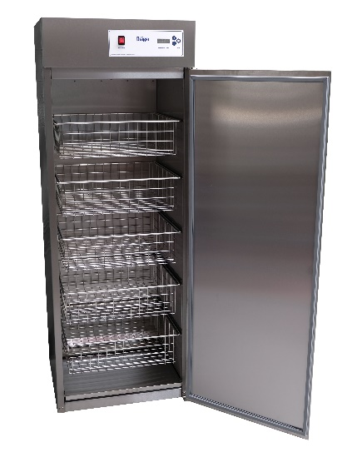
Dimensions :height x width x depth in inches
External : 66.14 x 23.70 x 23.77
Internal : 55.12 x 21.34 x 19.69
Content : 100 gallon
Net weight : 220 lbs
External : Stainless steel
Internal : Stainless steel
Doors : 1 Piece
Door sealing : magnetic strip
Drip tray : polished stainless steel
Adjustable legs : 4 pieces., adjustable for stability and spirit level
Insulation : glass wool, min. 1.2 inch thick
Temperature range : up to 135°F. set at 125°F. by manufacturer
Second temperature : self-adjustable
Temperature reading : digital LED reading
Expiring time clock : digital LED reading, set between 1 minute and 99:58 hours
Electronic temperature control : 2 pieces PTC sensors, solid state relay
Electronic moisture measure : capacitive sensor
Temperature safeguard : extra thermostat (max. 135°F.)
Heating : direct heating, 2 kW
Air circulation : by means of 1 low-noise ventilator
Air refreshment : by air outlet on top of the cabinet, PVC tube of Ø 1.25 inch
Air inlet : at bottom of the cabinet through a filter
Filter : Class F5, EN 779
Capacity : 5 pieces wire baskets, stainless steel and removable
Standard wire baskets : max. 9 masks/ face pieces, total 45 pieces
Drying time : approx. 2 hours, depending on the number of
masks and amount of moisture

Connections
Mains connection : 208 Volt AC, PE, 60 Hz.
Power : 2,1 kW, secured 1 x 16 Ampere
Electricity consumption : average 0,4 kWh
Approval : UL508A

