WASH 9U

PROFESSIONAL WASHING MACHINE

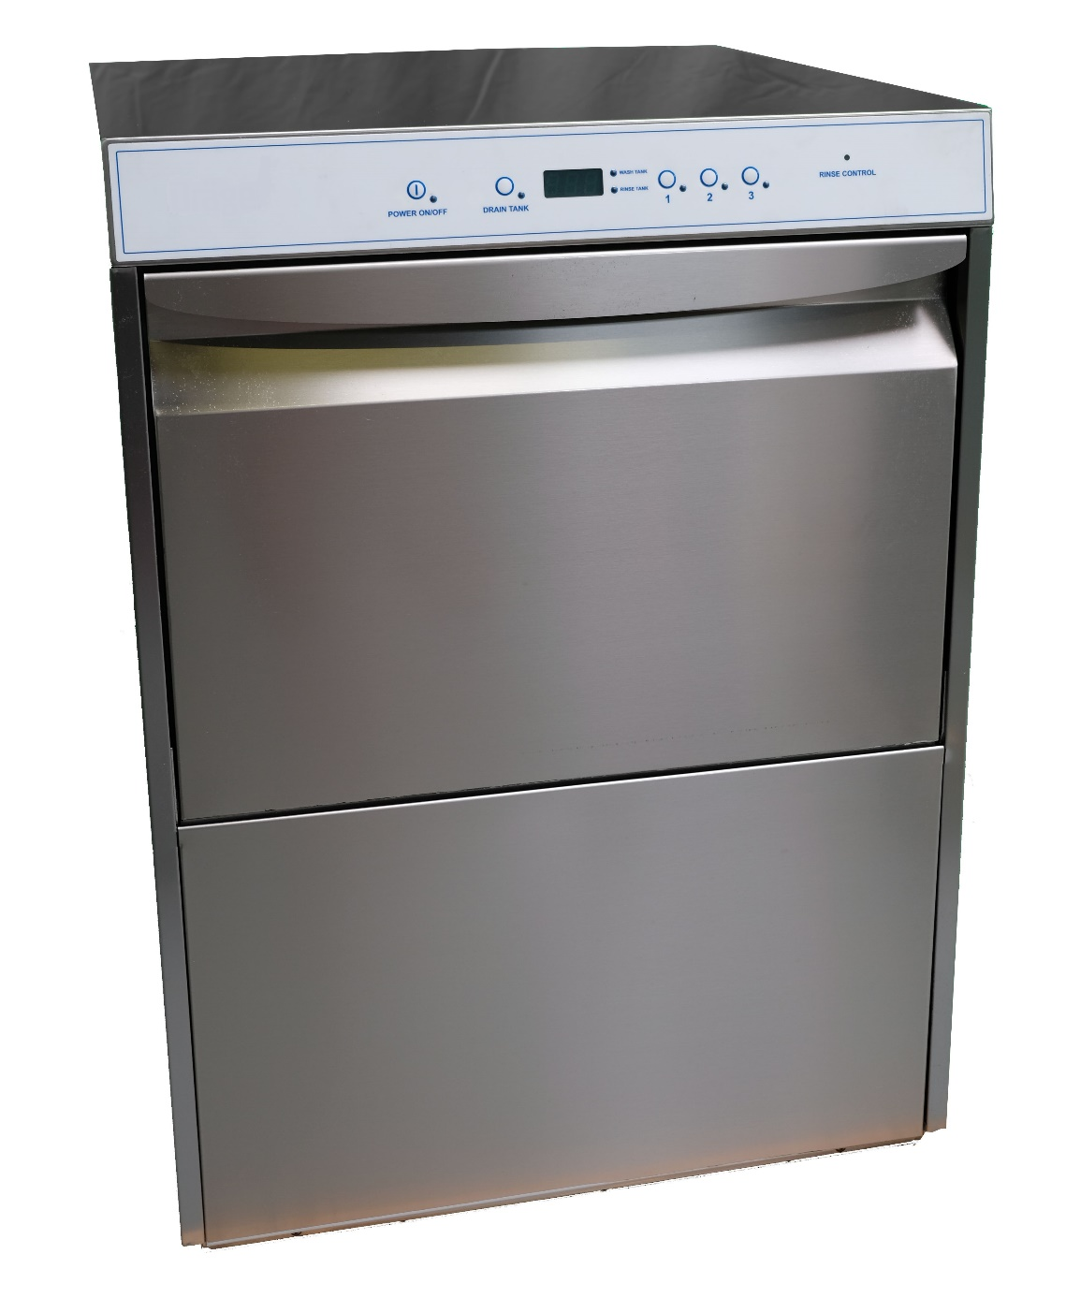

Version October 2025

Function
The washing machine Wash9U is ideally suited for the safe cleansing of breathing masks/face pieces. This takes place in combination with a cleanser based on a product which is liquid, mildly alkaline and phosphate and chlorine-free, while the neutralizing agent (applied after the rinsing agent) is based on citric acid.

Description
The washing machine is very compactly build in order to occupy as little space as possible. It is made entirely of stainless steel type 304 and is insulated against heat loss and noise emission.
In order to be able to cleanse the inside of the machine properly and easily, all corners are rounded and there are no sharp objects. Also the rotating stainless steel washing and rinsing arms with sprayers and the stainless steel sieve are easily removed.

The controls have been kept extremely simple, namely by 3 push-buttons for 3 different wash times ; 5, 10 or 21 minutes. You can read out the temperature for the tank and the boiler on the digital display.

The cleansing agent is dosed very precisely via a hose pump. The neutralizing agent is processed in the same way but with its own pump.

The machine has a low consumption of both water and electricity since the warm water of each rinsing is used and only the after-rinse is done with clean water from the boiler. This achieves a water consumption of 9 liters per cycle while the dirtiest water is removed. If required, it is possible to directly connect the machine to the warm water supply (max. 120°F.).
After the final rinse, you switch on the water removal pump in order to empty the tank.
With the cleansing machine, a stainless steel wire basket (A03) is supplied as standard. This basket also fits the M18UL and M45UL models drying cabinets.

Technical details:
The electronics, which operate all the units, has several sensors. Warning messages displayed on the control panel. A temperature safety device, which limits the temperature in the case of any breakdown, has been mounted on the boiler.
A door switch ensures that the machine does not start until the door is properly shut.
A clear signal lamp and LED-display indicate that the machine is in operation.
The washing machine must be connected to the power supply of 208 Volt, 2 phase and earthen.

The water connection is G 3/4" and a non-return valve has been installed through the user (in accordance to local regulations). The water hardness must be between 2-4° dH, otherwise a water softener system is recommended.

Maintenance:
The cleansing machine is easy to clean since it is made entirely of stainless steel. The inside part, such as the spray arms and sieves, can be easily removed so that a hygienic operation is guaranteed.

Model:
Wash9U for a maximum of 9 breathing masks (depending of model or type of masks).

Advantages compared to other washing machines:
- Specialy engineered en designed for breathing maskes.
- very fast cleansing cycles
- the masks do not need to be transferred to another basket
- lower consumption of both water and electrical energy
- simple to operate
- low noise level when in use
- virtually maintenance-free
- long life cycle
- a high quality product

PROFESSIONAL WASHING MACHINE TYPE WASH9U

Specifications
Dimensions height x width x depth in inches
External 33.46 x 23.62 x 24.41
Internal 13.39 x 21.26 x 18.90
Weight 150 lbs
External grinded stainless steel type 304
Internal stainless steel type 304
Doors 1 piece front (door Security/Emergency stop)
Feet’s 4 pieces adjustable for stability
Water connection /supply G 3/4" to max. 120°F. water hardness 2-4˚dH
Water pressure 7 – 100 PSI
Water consumption 2 gallon per wash cycle
Cleansing time approx. 5, 10 or 21 minutes
Wash tank content 5 gallon
Temperature wash water 125°F.
Rinse tank content 3 gallon
Temperature rinse water 131°F.
Temperature reading by LED reading
Temperature safety software: high level limit
Heating wash tank 2.2 kW
Heating rinse tank 6.0 kW
Water drain hose ø 1.14 inch
Hose pumps 1 x for dosage cleaning agent and 1 x for the neutralizing agent
Capacity max.9 breathing masks/face pieces per wash cycle
Number of wire baskets 1 piece (A03)
also fitting in our drying cabinets type M18UL and M45UL
Cleansing agent concentration 0.5%
Neutralizing agent concentration 0.05%

Connections
Voltage 3-pole cable, 208 Volt AC, 2 phases, PE, 60 Hz.
Power 33A
Water supply connection G ¾” max. 120°F.
Water hardness 2 till 4° dH
Required water pressure 7 – 100 PSI
Water consumption by rinse 2,25 gallon (rinsing time 40 seconds)
Water drain Ø 2 inch
Maximum height drain hose 7.87 inch without syphon
Noise volume 70 dB(A)

Optional Accessories

- A13: Stainless steel support frame
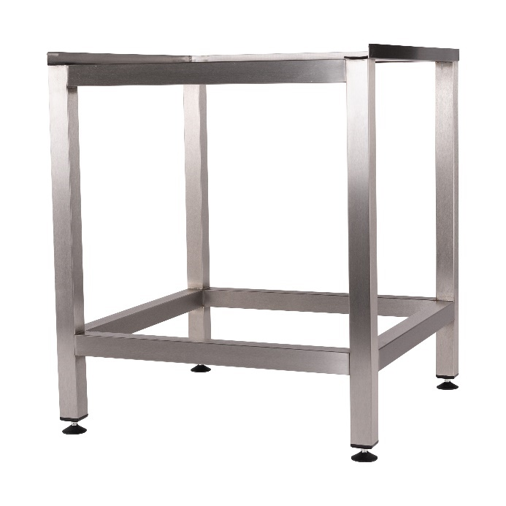
- A14: Stainless steel support frame closed with 1 door
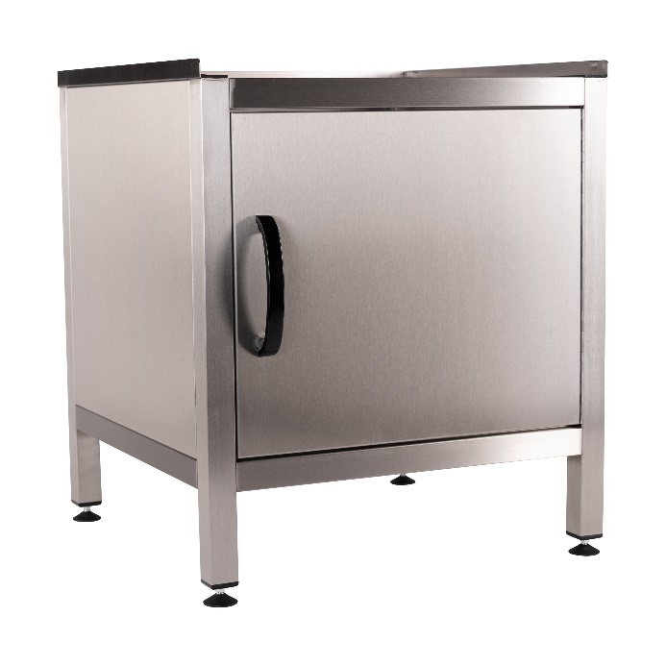

- A56: stainless steel fine mesh basket with 12 compartments and cover
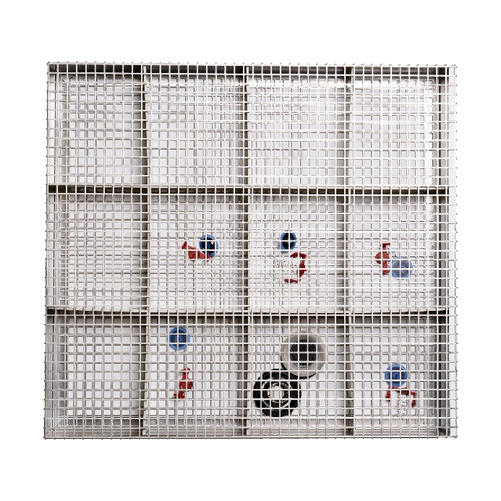
- A910: stainless steel fine mesh basket with 6 compartments and cover
